(Approx. 170 words)

PD40R V2 Variable Intensity Flashlight by Fenix
By George Harding, Treasurer, Tucson Computer Society
https://aztcs.apcug.org
actuary110 (at) yahoo.com

This flashlight is unusual in several aspects. It has no On/Off button but instead has a rotating switch that selects any of the four intensities and the strobe mode.
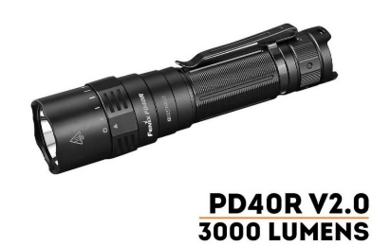
The intensities available through this switch are 30, 350, 1000, and 3000 lumens.

At the 3000-lumen intensity, the beam penetrates as far as 1400 feet and has a 65-degree width.

The strobe uses a 2500-lumen intensity.

The base is constructed so the flashlight can be used as a beacon for camping or more.

The included battery is rechargeable using the embedded USB-C port. The charge duration depends on the intensity level that you use.

The construction is heavy-duty aluminum and has an attached belt clip.

The flashlight is waterproof to a moderate degree (2 meters for 30 minutes).

This is a very useful tool, especially for those who work outdoors, such as police, firefighters, utility workers.

Fenix PD40R V2.0 Flashlight

https://www.fenix-store.com/fenix-pd40r-v2-0-flashlight/

Price $120

